DSA C++ SEQUENCE 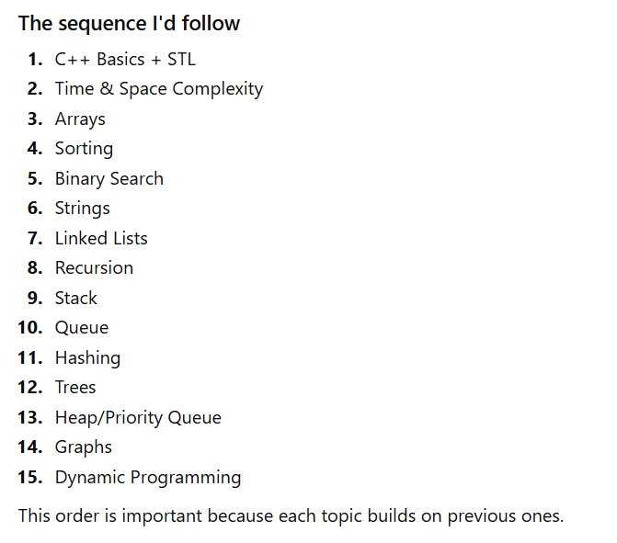
Absolutely. Since your goal is placements, not competitive programming, here's a roadmap that builds concepts in the right order.
STRONG ARRAY FOUNDATION WILL MAKE NEXT TOPICS LOOK EASY
📚 Arrays Roadmap (Complete)
🟢 Level 1 – Fundamentals (You already know most of this)
- ✅ What is an array?
- ✅ Memory representation
- ✅ Indexing (0-based)
- ✅ Traversal
- ✅ Input/Output
- ✅ Updating elements
Practice
- Print array
- Sum of array
- Average
- Max element
- Min element

🟡 Level 2 – Basic Operations
These strengthen traversal.
- Linear Search
- Count Even/Odd
- Count Positive/Negative
- Count Frequency (simple)
- Find Largest & Smallest
- Second Largest
- Check if array is sorted

🟠 Level 3 – Manipulation
Now you start modifying arrays.
- Reverse Array ⭐
- Swap Elements
- Copy Array
- Merge Two Arrays
- Concatenate Arrays
- Insert Element
- Delete Element
- Shift Left
- Shift Right

🔵 Level 4 – Two Pointer Technique ⭐⭐⭐⭐⭐
This is one of the biggest concepts.
Learn through problems:
- Reverse Array
- Sort 0 and 1
- Move Zeroes
- Remove Duplicates (sorted array)
- Pair Sum
- Two Sum (sorted)

🟣 Level 5 – Rotation
Very common in interviews.
- Left Rotate by 1
- Right Rotate by 1
- Left Rotate by K
- Right Rotate by K
- Cyclic Rotation

🟤 Level 6 – XOR Tricks ⭐⭐⭐⭐
Understand why XOR works.
Problems:
- Find Unique Element
- Missing Number
- Duplicate Number (basic cases)

🔴 Level 7 – Dutch National Flag ⭐⭐⭐⭐⭐
Only a few problems, but an important pattern.
- Sort 0s & 1s
- Sort 0s,1s,2s

🟠 Level 8 – Prefix Sum ⭐⭐⭐⭐⭐
One of the most useful concepts.
Learn:
- Prefix Sum Array
- Running Sum
- Range Sum Query
- Equilibrium Index (optional)

🟢 Level 9 – Kadane's Algorithm ⭐⭐⭐⭐⭐
Must know for interviews.
- Maximum Subarray Sum
- Maximum Circular Subarray (later)

🔵 Level 10 – Hashing with Arrays
Start combining arrays with hash maps.
Problems:
- Frequency Count
- Two Sum
- Majority Element
- First Repeating Element
- Missing Number (Hashing)

🟣 Level 11 – Sliding Window ⭐⭐⭐⭐⭐
Very important pattern.
Learn:
- Fixed Window
- Variable Window
Problems:
- Maximum Sum of K Elements
- First Negative in Every Window
- Longest Subarray

🟤 Level 12 – Advanced Array Problems
After all the above.
- Next Permutation
- Merge Intervals
- Product Except Self
- Leaders in Array
- Rearrange Positive & Negative
- Trapping Rain Water
- Container With Most Water

🎯 Order I'd recommend for you
Basics
↓
Linear Search
↓
Max / Min
↓
Reverse Array
↓
Second Largest
↓
Insert/Delete
↓
Shift
↓
Rotation
↓
Two Pointers
↓
Move Zeroes
↓
Sort 0s & 1s
↓
Sort 0s,1s,2s
↓
XOR
↓
Prefix Sum
↓
Kadane
↓
Hashing
↓
Sliding Window
↓
Advanced Problems
💡 Since you're following Love Babbar
Don't worry if his playlist mixes concepts with problems. A lot of DSA concepts are best learned through representative problems.
For each topic:
- 📖 Understand the idea (why it works).
- 💻 Code it yourself without copying.
- 🧪 Dry run on paper with a small example.
- 🔁 Solve 2–3 similar questions.
That process will build much stronger intuition than watching lots of theory.
One small suggestion: don't rush to "finish arrays in 2 days" if it means skipping understanding. Spending 4–5 days and truly mastering these patterns will make the rest of DSA (binary search, strings, linked lists, etc.) much easier. A strong array foundation pays off throughout your DSA journey. 💪

